Mobilizing our Airmen - Isobar

**A Project Report**

**By**

**Nikita Saple**

**(001686003)**

**In partial fulfilment for the course**

**Of**

**CSYE 7250 – BIG DATA ARCHITECTURE AND GOVERNANCE**



PROFESSORS:

**KAMBIZ HEYDARI**

**NORTHEASTERN UNIVERSITY**

**360 HUNTINGTON AVE., BOSTON, MASSACHUSETTS 02115**

**APRIL 2017**

**Table of Contents**

1. Project Overview………………………………………………………………………………………………………3
   1. Mission statement…………………………………………………………………………………………3
   2. Vision Statement………………………..…………………………………………………………………3
2. Problem Statement……………………………………….……….………………………………………………………3
   1. Risks and Issues..………………………….……….………………………………………………………4
3. Strategy and Roadmap………………………………….……….…………………………………………….…………4
   1. Scope………………………………….……….…………………………………………………....…………4
   2. Major Deliverables………………………………….……….……………………………………………4
   3. Roadmap………………………………….……….………………………………………………….………4
   4. Objectives………………………………….……….………….……………………………………………..5
4. Requirements………………………………….……….…………………………………….………………………………5
   1. Functional Requirements……………………….………….……….……………………………5
   2. Non - Functional Requirements………………………………….……….………………..…6
   3. Sandbox approach………………………………….……….………………………………………7
5. Architecture………………………………….……….………………….………………….…………………………..……8
   1. Visualization………………………………….………..………………………………….…………………8
   2. Orchestration………………………………….……….……………….…………………..………………9
   3. Language………………………………….……….…………………………….……………………………9
   4. Database………………………………….……….….……………………………….………………………9
   5. Framework………………………………..……….……….………………………………………………10
   6. Integration……………………………………….….…….………………………………….……………11
   7. Security………………………………….…………..……………………………………………………….12
   8. Scalability………………………………….…….………………………………………………………….15
   9. Manageability…………………………………..…………...……………………………………………15
6. Big data governance………………………………….…….….…………………………………….………………….16
7. Quality Expectations………………………………….…….….…………………………………….…………………18
8. Organization Structure………………………………….……….…………………………………….………………18
9. References………………………………….……….………….………………………….…………………………..……19
10. **Project Overview**

Isobar is a global, full-service, digital agency with innovation at its heart. With its Brand Commerce expertise and Product and Service Design capabilities, it creatively solves complex client challenges - delivering positive business results for many brands, including Adidas, Coca-Cola, Royal Caribbean Cruises Ltd., Google, Enterprise Rent-A-Car, Kellogg's and P&G.

* 1. **Mission statement**

Isobar brings into existence applications and digitally centered marketing campaigns for mobiles devices, web and social media.

* 1. **Vision Statement**

By creating, conceiving and optimizing “Ideas without Limits”, Isobar intends to resolve complex client challenges and render incontrovertible business results to become the preferred choice in digital media.

The Air Force has developed a predictive readiness model called the five levers of readiness that must be in sync with each other for success. These are: the flying hour program, weapons system sustainment, critical skills availability, training resource availability, and deploy to dwell/ops tempo.

Isobar aims at designing a Programmatic engine that can be used to handle the air traffic and weather conditions and enhance synchronization between the five levers of readiness.

1. **Problem Statement**

A survey was done with the employees of the Airforce and the researchers that are using the current system. The survey showed that the decisions made in the past based on the reports generated have been helpful at times, though the analysis has been off a while and the timing has not been kind.

There is still a significant amount of information that is not yet captured in digital form, e.g., data that are on paper, or not made easily accessible and searchable through networks. We found that up to 25 percent of the effort in some knowledge worker workgroups consists of searching for data and then transferring them to another (sometimes virtual) location. This effort represents a significant source of inefficiency.

More accurate and detailed performance information needs to be collected to expose variability and boost performance. Controlled experiments need to be undertaken to make better management decisions.

The need to narrow segmentation of customers causing precisely tailored services.

Sophisticated analytics can substantially improve decision-making, minimize risks, and unearth valuable insights that would otherwise remain hidden.

Big Data can be used to develop the next generation of products and services. For instance, manufacturers are using data obtained from sensors embedded in products to create innovative after-sales service offerings such as proactive maintenance to avoid failures in new products.

**2.1** **Risks and Issues**

RISKS

* Data Quality
* Security
* Cost Management

ISSUES

* Talent Shortage
* Scalability Challenge

1. **Strategy and Roadmap**
   1. **Scope**

Support Airmen with easier, more secure access to information

Exiting issues:

* The old system had become cluttered.
* Difficult to navigate and didn’t support mobile access.
* Joining Data from multiple RDMS sources and combining
* Multiple factors from several records is not feasible.
* For faster and easier processing, and to achieve in depth analytics for the airmen, big data solution would be appropriate.
  1. **Major Deliverables**
* **Big Data can unlock significant value by making information transparent.**
* **Organizations can create and store more transactional data in digital form**
* **Big Data allows ever-narrower segmentation of customers and therefore much more precisely tailored products or services.**
* **Sophisticated analytics can substantially improve decision-making, minimize risks, and unearth valuable insights that would otherwise remain hidden.**
* **Big Data can be used to develop the next generation of products and services.**
  1. **Roadmap**

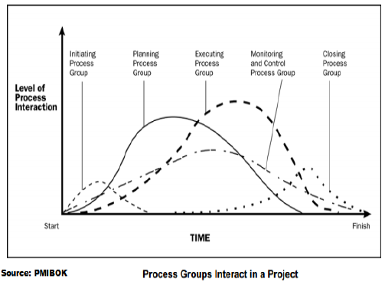

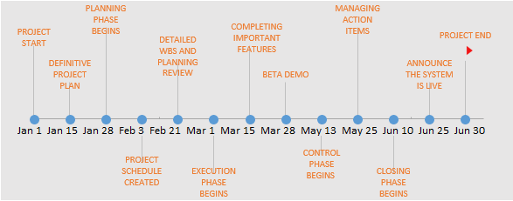

The project begins on January 1, 2017 and is estimated to end on June 30, 2017. Due to several factors that have to be considered for the smooth transition of this system, the end date may vary and certain milestones may need more time for completion as compared to the roadmap above.

* 1. **Objectives**
* Social Media Analytics to Find the Enemy
* Knowledge Management to Improve the Organization
* A Cloud Solution for 800.000 Air Force Users
* Reducing Energy Consumption at Air Forces Bases (Big data + IOT using sensors – use splunk for data)
* Improved Battlefield Analytics to Reduce Collateral Damage (The video data is combined with sensor data and using trend detection algorithms it allows analysts to observe, track and potentially predict enemy force operations based on their observed behavior.)

1. **Requirements**
   1. **Functional Requirements**
2. Historical Data

* Historical data is present in the form of relational tables that need to be migrated to an unstructured format in order to accommodate big data methodologies.
* Data Profiling would take care of the tables, their attributes and the data that they handle.
* Data transfer from legacy version to the new version.
* Data security would continue to monitor users.

1. Authentication and Authorization

Authentication and Authorization Requirements play an important role while defining functional requirements for system. They provide user access information and provide security to the system.

* **Authentication**: It involves management of system access with respect to user. Authentication is a process by which you verify that someone is who they claim they are.
* **Authorization**: Authorization is the process of establishing if the user (who is already authenticated), is permitted to have access to a resource. Authorization determines what a user is and is not allowed to do.

1. Audit Tracking or Audit Logs

Audit tracking is one of the functional requirement for a system which is of significant importance. An audit trail or audit tracking (also called audit log) is a security-relevant chronological record, set of records, and/or destination and source of records that provide documentary evidence of the sequence of activities that have affected at any time a specific operation, procedure, or event.

1. Upgraded UI

A few upgrades will be made to the UI which will provide a variety of configuration options.

1. Reports

A detailed report will be generated of the data which has undergone rigorous analysis along with the results.

1. Alerts and Warnings

The system will provide various alerting mechanisms to communicate the status of the various operations the data is undergoing. Any data that is corrupted or out of place will also be notified.

1. Alerts and Warnings Report

A full report of all the alerts and warnings encountered in a particular timeline will be generated.

1. Archive Data

Once the data has gone through several cycles of analysis and is not needed, it is archived in a separate warehouse so only the critical data is stored in the data center.

* 1. **Non - Functional Requirements**

1. No data loss in streams
2. Handle streaming data while it is flowing in
3. Handle heterogeneous data sources
4. Availability of past data
5. Updating the models, data sources and visualization layouts
6. Scalability of the system
7. Ensure data privacy and security
8. Disaster recovery

Big Data Projects are complex. Complexity arises from the fact that there are multiple data sources, many ways of storing data, and a large team with diverse skill sets and different backgrounds working on the project. There will be multiple approaches to a single task. So the first step is to break up the plan into smaller components aka a work breakdown structure (WBS). This way each task is broken down into a smaller portion, owners are assigned for each of these tasks, and it is easier to trace the progress of each of these tasks.

**4.3** **SANDBOX APPROACH**

Sandboxing is a good approach to ensure success of a Big Data project. Sandboxing involves an isolated computing environment. Obtaining huge volumes of data in one go is replaced by acquiring data from a single source.

Data scientists manipulate the data, build models using the data, and understand the results being produced. This will help understand the data better, ensure that the right data is being sourced, and help decide on the technologies to be used when moving to large scale production.

The sandbox approach is a very effective method of ensuring that robust requirements are developed and will help evolve the requirements in an incremental manner. This approach will also help refine requirements.

1. **Architecture**

**Current Architecture**

In 1952, when the NSA was founded, they quickly employed thousands of cryptologists to deal with the massive amounts of data that was flowing into the organization. Since then, governments from around the world have been analyzing large streams of data. Therefore, the armed forces have also been using data, and more lately big data, to gather intelligence and optimize the organization.

**Proposed Architecture**

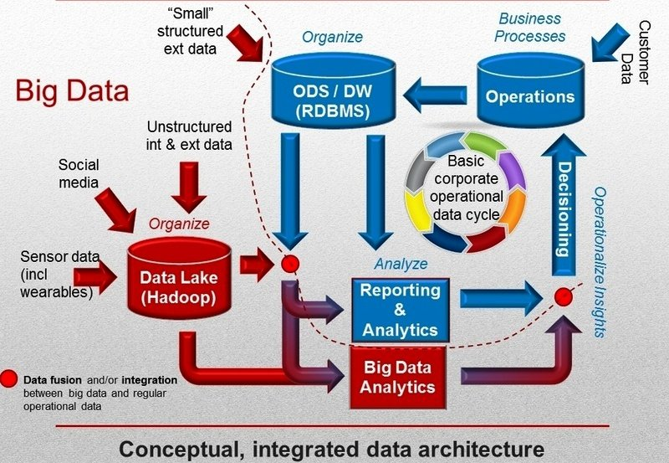

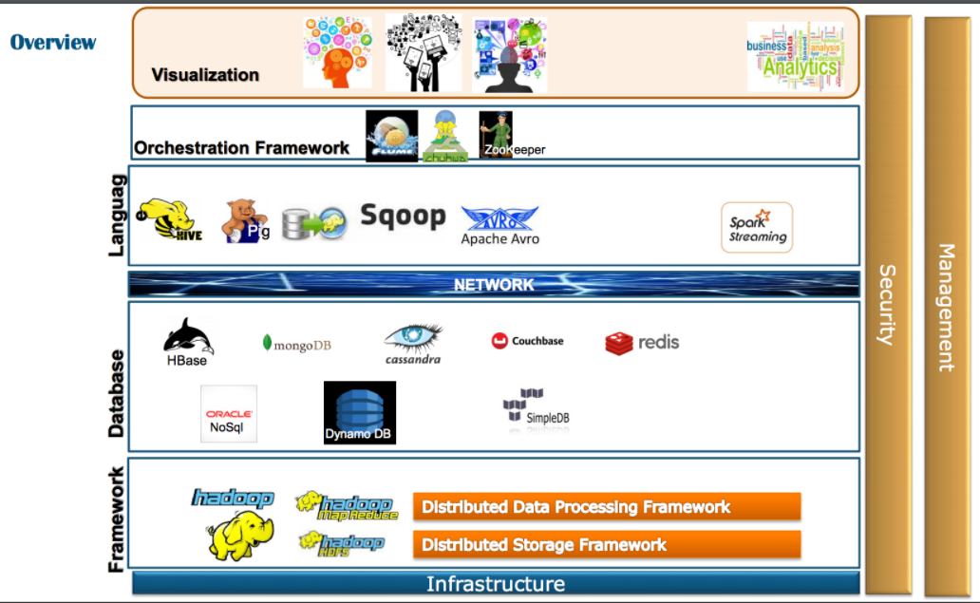

* 1. **Visualization**

Tableau is a Business Intelligence tool for visually analyzing the data. Users can create and distribute interactive and shareable dashboards which depict the trends, variations and density of the data in form of graphs and charts. Tableau can connect to files, relational and Big data sources to acquire and process data.

The software allows data blending and real time collaboration. Tableau will prove to be ideal due to its ability to handle huge data sets. Tableau will be useful for visually representing satellite data which was analyzed and will give a clearer picture. Tableau is fast and has an easy to use intuitive interface.

* 1. **Orchestration**

**Apache Flume** is a distributed, reliable, and available service for efficiently collecting, aggregating, and moving large amounts of log data (Hadoop Distributed File System (HDFS).). It has a simple and flexible architecture based on streaming data flows. It is robust and fault tolerant with tunable reliability mechanisms and many failover and recovery mechanisms. It uses a simple extensible data model that allows for online analytic application.

Due to huge amounts of Satellite data generated per second, Flume can prevent data loss and is highly reliable. When the data reaches the data centers, Flume will transfer the data to HDFS. Flume will be compatible with other Hadoop based tools used and will enable smooth working.

Along with Flume, Apache Zookeeper will prove to be useful for distributed configuration service and synchronization service. Due to parallel complex systems it will provide a centralized infrastructure and services that enable synchronization across a cluster. Applications can leverage these services to coordinate distributed processing across large clusters. With so many clusters containing huge data, synchronization will be extremely important and Zookeeper will be vital for the success of the project.

* 1. **Language**

Go language developed by Google is suitable for the project.

Go language enhances processing on large datasets. Go compiles very quickly and supports concurrency at the language level. Go has garbage collection. Strings and maps are built into the language.

Go can be combined with Hive language called Beeline. HiveServer2 and a JDBC client (such as Beeline) as the primary way to access Hive. Hive data can also be accessed from other applications, such as Pig. For these use cases, use the Hive CLI and storage-based authorization.

* 1. **Database**

The purpose to setup a database for this project is to resolve the practical issues of storing all the data. We are dealing with analysis and production that is "the conversion of processed information into intelligence through the integration, evaluation, analysis, and interpretation of all source data and the preparation of intelligence products in support of known or anticipated user requirements" (JP 2-01). It intends to provide the ability to integrate, evaluate, and interpret information/data from available sources to create a finished intelligence product for presentation or dissemination to enable increased situational awareness.

Data at hand is in exabytes and requires a highly scalable database. The database used is a combination of Apache Hive and HBase.

* 1. **Framework**

**Hadoop** consists of the Hadoop Common package, which provides file system and OS level abstractions, a MapReduce engine (either MapReduce/MR1 or YARN/MR2) and the Hadoop Distributed File System (HDFS). The Hadoop Common package contains the necessary Java archive (JAR) files and scripts needed to start Hadoop.

For effective scheduling of work, every Hadoop-compatible file system should provide location awareness: the name of the rack (more precisely, of the network switch) where a worker node is. Hadoop applications can use this information to execute code on the node where the data is, and, failing that, on the same rack/switch to reduce backbone traffic. HDFS uses this method when replicating data for data redundancy across multiple racks. This approach reduces the impact of a rack power outage or switch failure; if one of these hardware failures occurs, the data will remain available.

A small Hadoop cluster includes a single master and multiple worker nodes. The master node consists of a Job Tracker, Task Tracker, NameNode, and DataNode. A slave or worker node acts as both a DataNode and TaskTracker, though it is possible to have data-only worker nodes and compute-only worker nodes. These are normally used only in nonstandard applications.

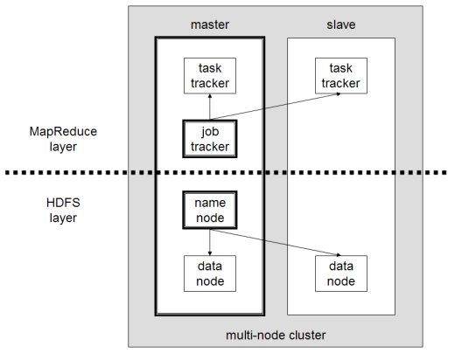

Big data: 5 major advantages of Hadoop

1. Scalable

Hadoop is a highly scalable storage platform, because it can store and distribute very large data sets across hundreds of inexpensive servers that operate in parallel. Unlike traditional relational database systems (RDBMS) that can't scale to process large amounts of data, Hadoop enables businesses to run applications on thousands of nodes involving thousands of Exabyte of data.

2. Cost effective

Hadoop also offers a cost effective storage solution for businesses' exploding data sets. Hadoop, is designed as a scale-out architecture that can affordably store all of a company's data for later use. The cost savings are staggering: instead of costing thousands to tens of thousands of pounds per terabyte, Hadoop offers computing and storage capabilities for hundreds of pounds per terabyte.

3. Flexible

Hadoop enables businesses to easily access new data sources and tap into different types of data (both structured and unstructured) to generate value from that data. This means businesses can use Hadoop to derive valuable business insights from data sources such as social media, email conversations or clickstream data. In addition, Hadoop can be used for a wide variety of purposes, such as log processing, recommendation systems, data warehousing, market campaign analysis and fraud detection.

4. Fast

Hadoop's unique storage method is based on a distributed file system that basically 'maps' data wherever it is located on a cluster. The tools for data processing are often on the same servers where the data is located, resulting in much faster data processing. If you're dealing with large volumes of unstructured data, Hadoop is able to efficiently process terabytes of data in just minutes, and petabytes in hours.

5. Resilient to failure

A key advantage of using Hadoop is its fault tolerance. When data is sent to an individual node, that data is also replicated to other nodes in the cluster, which means that in the event of failure, there is another copy available for use.

The MapR distribution goes beyond that by eliminating the NameNode and replacing it with a distributed No NameNode architecture that provides true high availability. Our architecture provides protection from both single and multiple failures.

When it comes to handling large data sets in a safe and cost-effective manner, Hadoop has the advantage over relational database management systems, and its value for any size business will continue to increase as unstructured data continues to grow.

* 1. **Integration**

**Talend Big Data** was designed to simplify the development, integration and management of big data by removing the need for users to learn, write or maintain complicated Hadoop or Spark code. Talend provides native and optimized code generation to load, transform, enrich, and cleanse data inside Hadoop without additional storage or computing expense.

Talend Data Integration is an open and scalable data integration and data quality solution for integrating, cleansing and profiling all corporate data. The product features over 900 prebuilt components to connect various data sources. It also offers collaboration and management tools.

Big data integration is a key operational challenge to manage petabytes of data in a way that delivers genuine value to business users. Talend Open Studio for Big Data greatly simplifies the process of working with Hadoop. Apache's open source MapReduce implementation that's rapidly become the leading framework for computational processing of massive data sets. With Talend's open source big data integration software, you can move data into HDFS or Hive, perform operations on it, and extract it without having to do any coding.

Talend is easily compatible with Hive and Spark and data integration will be seamless. Talend can also handle huge datasets from multiple data source especially when handling legacy data. Talend can also transfer structured and unstructured data. This tool will prove to be useful and work optimally with the current environment setup.

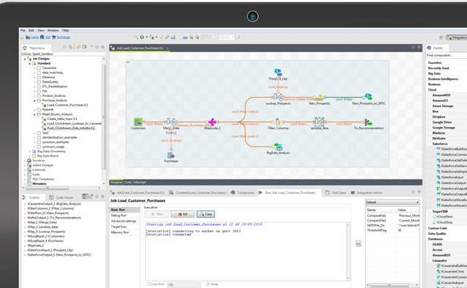

* 1. **Security**

Security challenges faced while planning the project are as follows

* Most distributed systems’ computations have only a single level of protection, which is not recommended.
* Non-relational databases (NoSQL) are actively evolving, making it difficult for security solutions to keep up with demand.
* Automated data transfer requires additional security measures, which are often not available.
* When a system receives a large amount of information, it should be validated to remain trustworthy and accurate; this practice doesn’t always occur, however.
* Unethical IT specialists practicing information mining can gather personal data without asking users for permission or notifying them.
* Access control encryption and connections security can become dated and inaccessible to the IT specialists who rely on it.
* Some organizations cannot – or do not – institute access controls to divide the level of confidentiality within the company.
* Recommended detailed audits are not routinely performed on Big Data due to the huge amount of information involved.
* Due to the size of Big Data, its origins are not consistently monitored and tracked.

These issues can be resolved by undertaking the following:

**1. Identify and Protect Sensitive Data**

If you assume that determined hackers can breach your perimeter security, it becomes far more important to ensure they can’t get away with anything of value if they do. This is crucial for data security.

Understand the nature of any data you are storing and/or processing and protect it accordingly.

Make sure any sensitive data (whether stored or in transit) is hidden from prying eyes by strong encryption and access is tightly controlled.

**2. Know Who’s Accessing It, And How**

Simple password protection is not enough – even with automated checks in place - to ensure that users select strong passwords and change them regularly. You can never be 100% sure people haven’t being tricked into revealing their password or if they are logging in to your company’s systems from unsafe devices.

Make sure you implement strong access and authentication tools and controls that will not permit users to access sensitive data unless the security of the device and network they’re using can be verified.

Two-factor (or multi-factor) authentication can also help ensure a compromised password alone is not enough to grant hackers access to your network and systems.

**3. Log Everything**

To keep constant tabs on any potentially suspicious activity occurring on your network, you’ll need an up-to-date SIEM (security information and event management) system such as Splunk, IBM Q-Radar or LogRhythm.

These are an essential security radar when it comes to identifying APTs. They collate information in real time from many sources (including security systems, emails, social network activity, business process and operations data, cameras, sensors, network activity, external threat information feeds and more) and alert you when they spot anything awry.

More advanced logs can also hook into advanced data security analytics tools for even smarter protection.

**4. Shutdown Threats Quickly**

Being able to spot threats is one thing, but you’ll also need to deal with them quickly. Ensure you have sufficient resources and skills (either in-house or external) to monitor alerts and network activity and respond rapidly and appropriately, using IT forensics when necessary.

Networks should be well-segmented internally, so that sensitive data and systems are ring-fenced, threats can be contained without system-wide shutdown and lateral movement by hackers inside the network can be thwarted effectively.

You need the same level of monitoring and control for external cloud systems as for internal infrastructure, so ensure your cloud provider offers sufficient flexibility, remote monitoring and controls to allow this.

**5. Don’t Underestimate the Cultural Hurdles**

Moving from a traditional security architecture to a data-driven intelligence and response model is a major change with significant cultural implications.

Ensure your security team understands why such a change is necessary, and work hard to ensure they are fully on board.

Other steps that can be undertaken are as follows:

**Application Software Security**

Using secure open source applications is of paramount importance. Big data technologies weren’t originally designed with security in mind. Using open-source technologies like Apache Spark and certain versions of Hadoop can help address this challenge.

**Maintenance, Monitoring, and Analysis of Audit Logs**

Keep in mind that security engineers in the organization need to be tasked with examining and monitoring these files. It’s important to ensure that auditing, maintaining, and analyzing logs are done consistently across the enterprise.

**Secure Configurations for Hardware and Software**

Build servers based on secure images for all systems in your organization’s big data architecture.

**Account Monitoring and Control**

Manage accounts for big data users. Require strong passwords, deactivate inactive accounts, and impose a maximum permitted number of failed log-in attempts to help stop attacks from getting access to a cluster. This can be handled using Hive, HBase and Tableau.

**Authentication and Authorization**

Each tool provides their own form of security like,

1. Talend: LDAP Authentication
2. Tableau: SAML and OAuth Authentication, Roles and permissions, Data and Network Security
3. Hive: Kerberos authorization support, SASL Integration
4. HBase: Kerberos authorization support, Server-side/Client-side Configuration for Secure Operation with Thrift and REST gateway
5. Apache Flume: Kerberos Security
   1. **Scalability**

**Hadoop,** Rather than capping your data throughput with the capacity of a single enterprise server, Hadoop allows for the distributed processing of large data sets across clusters of computers, thereby removing the data ceiling by taking advantage of a “divide and conquer” method among multiple pieces of commodity hardware.

While this architecture was the beginning of the data scalability revolution, it is by no means the end.

**Talend** 5.5 enhances Talend’s performance and scalability on Hadoop by an average of 45 percent. Adoption of Hadoop is skyrocketing and companies large and small are struggling to find enough knowledgeable Hadoop developers to meet this growing demand. This unlocks a large pool of development resources that can now contribute to big data projects. In addition, Talend is staying on the cutting edge of new developments in Hadoop that allow big data analytics projects to power real-time customer interactions.

**Flume** Scalability is the ability to increase system performance linearly - or better - by adding more resources to the system. Flume’s goal is horizontal scalability — the ability to incrementally add more machines to the system to increase throughput. A key performance measure in Flume is the number or size of events entering the system and being delivered. When load increases, it is simple to add more resources to the system in the form of more machines to handle the increased load.

* 1. **Manageability**

**Apache Flume**

**Flume manageability** is its ability to control data flows, monitor nodes, modify settings, and control outputs of a large system. Manually managing the data flow from the sources to the end point is tedious, error prone, and a major pain point. With the potential to have thousands of log-generating applications and services, it’s important to have a centralized management point to monitor and change data flows, and the ability to dynamically handle different conditions or problems.

The Flume Master is the point where global state such as the data flows can be managed. Via the Flume Master, users can monitor flows and reconfigure them on the fly. The Flume Master has the information required to automatically respond to system changes such as load imbalances, partial failures, or newly provisioned hardware.

**HBase and Hive**

1. Data backup and Recovery
2. Performance Tuning
3. Data Modeling and Schema Evolution
4. Data Pruning
5. Online Expansion and Upgrade
6. HBase proves to fit really well in the Hadoop environment. It increases efficiency of hard disk access, lowers latency and high throughput by enabling fast, random reads and writes to data.

**6.** **Big data governance**

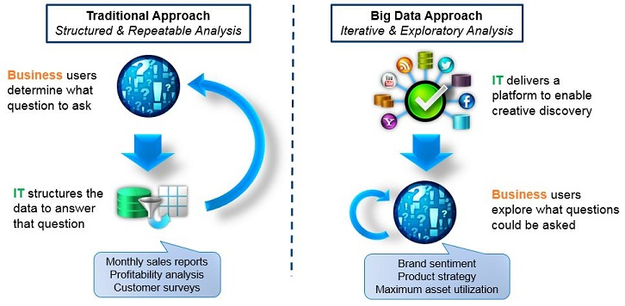

Data governance (DG) refers to the overall management of the availability, usability, integrity, and security of the data employed in an enterprise. A sound data governance program includes a governing body or council, a defined set of procedures, and a plan to execute those procedures**.**

In order to ensure data governance, 3 main areas have to be considered

**People**: An organized structure of highly skilled people have been considered for the data governance program.

The Stakeholders will also be an integral part of the process as they will be providing feedback and get regular updates on the progress of the program.

**Process**: The effective measurement of data governance program is a basic component of a successful program. Due to the sensitivity of the data, strict policies for the access of data has to be maintained. Regular backups, in case of data disaster can prove to be vital to success of the project.

**Framework and Practice:**

1. Rules and policies
2. Data will be combined from multiple data.
3. Balanced, Lean Governance: Implement Data Governance best practices.
4. Data Access: Increasing access to data while handling Data Security.
5. Data Literacy.
6. Analytic Prioritization: Develop the strategic analytic plan for the C-level suite. Ensure the requirements of that plan are implemented.
7. Master Data Management: Using conformed dimensions.

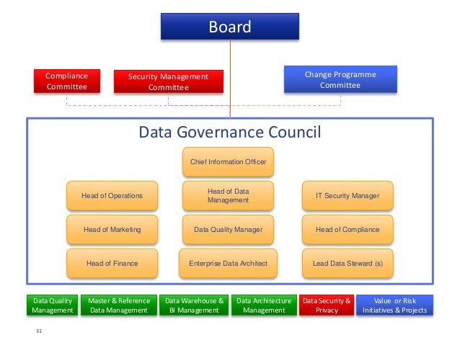

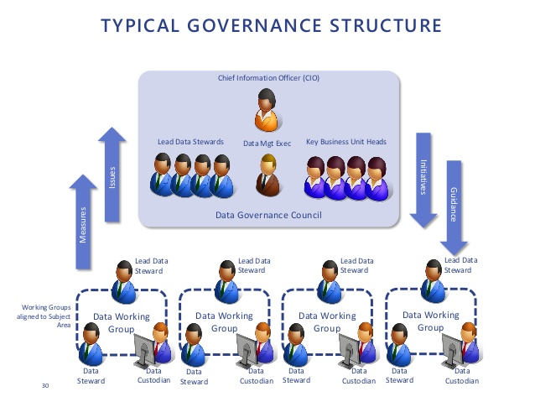

1. **Quality Expectations**

In order to attain quality expectations we must do the following:

1. Defining your business use case- with clearly defined objectives driving business value.

2. Planning your project- a well-managed plan and scope will lead to success.

3. Defining your technical requirements- detailed requirements will ensure you build what you need to reach your objectives.

4. Creating a “Total Business Value Assessment”- a holistic solution comparison will take the politics (and emotion) out of the choices.

Quality expectations include:

1. System should perform deep and accurate analysis.
2. System should generate detailed report faster than the current system.
3. Configurations of old system must hold and additional must be added.
4. Data integrity and quality must be maintained throughout.
5. Database must handle huge incoming data from mission assets.
6. **Organization Structure**

A process group is a logical grouping of activities, inputs tools techniques and outputs required for any type of project.

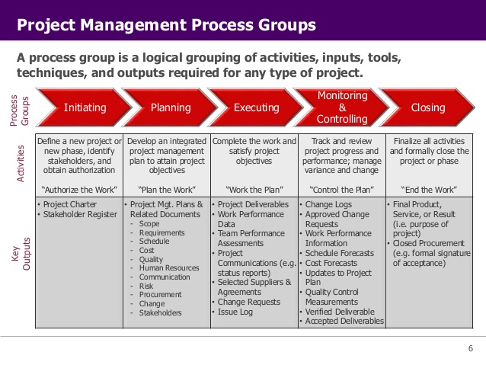

|  |  |
| --- | --- |
| Process Groups | Resources |
| Initiation | Business Analyst, Data Architect, Senior Developers, Project Managers, Project Engagement Team, Sponsors |
| Planning | Data Architects, Database Developers, Project Managers, Senior Developer, Business Analyst, Project Manager |
| Execution | Developers, Data Scientists, BI Developer, Project Manager |
| Monitoring and Control | Performance Engineers, Developer, QA Team and Information Security Analysts |
| Closure | Support Team and Project Manager |

**References**

* http://www.isobar.com/us/en/
* http://neu11.myvelero.com/VPPMMenu.cfm?Menu=2&winH=672&winW=1577
* http://www.isobar.com/se/en/privacy/
* https://isobar-idev.github.io/code-standards/
* https://www.mja.com.au/journal/2009/190/11/isobar-concept-and-handoverchecklist-
* national-clinical-handover-initiative
* http://nightwatchjs.org/
* http://bobchesley.net/front-end-code-standards-best-practices-roundarch-isobar/
* http://www.slideshare.net/yoav-netcraft/roundarch-isobar-java-script-codingstandards
* http://www.dentsuaegisnetwork.com/m/enuk/
* responsibility/code%20of%20conduct/dentsu%20aegis%20network%20code%
* 20of%20conduct.pdf
* http://www.isobar.com/us/en/terms/
* https://en.wikipedia.org/wiki/Roundarch_Isobar
* http://www.businesswire.com/news/home/20110228005609/en/Isobar-Expands-
* Creative-Leadership-Addition-Max-Fresen
* http://www.isobar.com/us/en/services/platforms/
* http://www.isobar.com/us/en/services/
* http://www.isobar.com/us/en/services/strategy/
* https://isobarmarketingintelligence.com/aboutus/
* <http://www.dentsuisobar.com/en/about_us/>